|  |  |  |  |  |  |
| --- | --- | --- | --- | --- | --- |
| Date | 23-Nov-22 | | | Tester Name | Richard Belanger |
| Environment | Penfax - Test | | | Login used | TEST2 |
| Operating System | Windows | Version: | Update: | | |
| Software Used | Edge | Version: | Update: | | |
| Not Applicable | Version: | Update: | | |
| Release version | 22.4.1 | | | | |
| Title | M2.09 Change member from Designated to General; and General to Designated | | | | |
| Test Type | Regression | | | | |
| Test Scenario | In PENFAX change a member from Designated to General; and General to Designated | | | | |
|  |  | | | | |
| Expected Results | The member will change to Designated to General | | | | |
| Pass/Fail | Pass | | | JIRA# | N/A |

Describe your steps with screenshots:

SID = 114035; Member is Designated

PENFAX

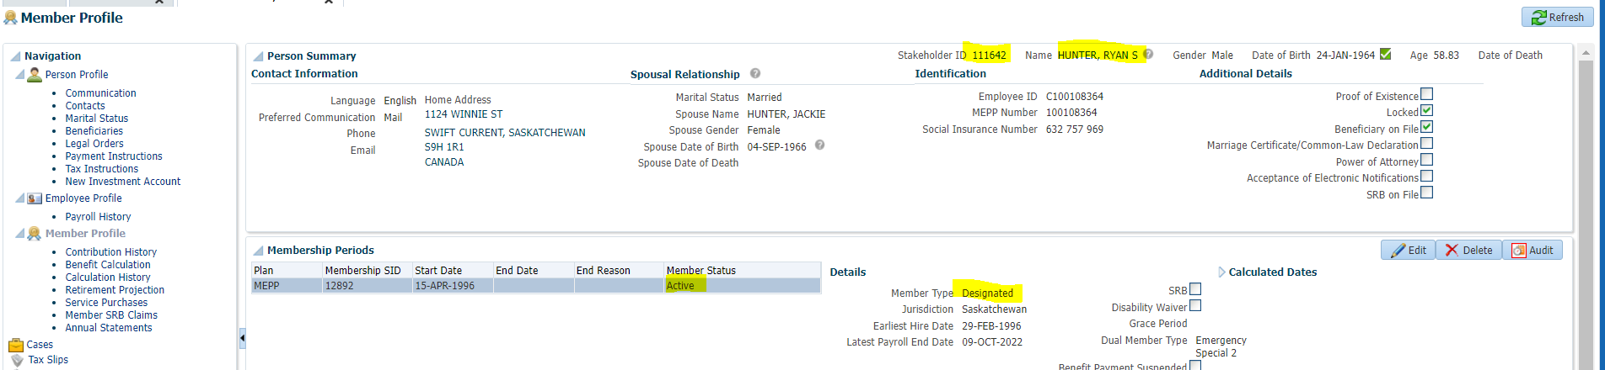

PENWEB

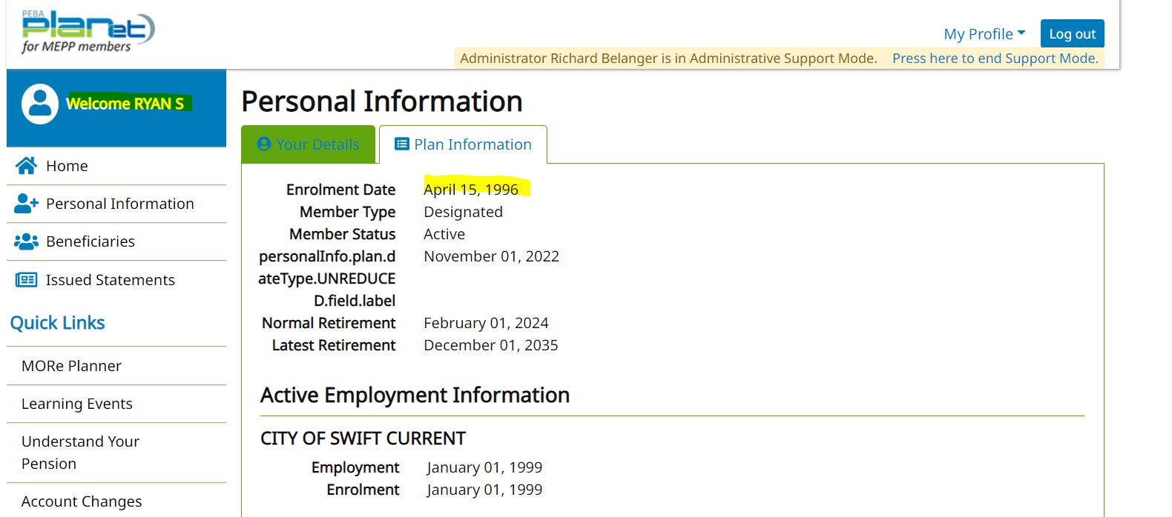

Change member’s Member Type to General

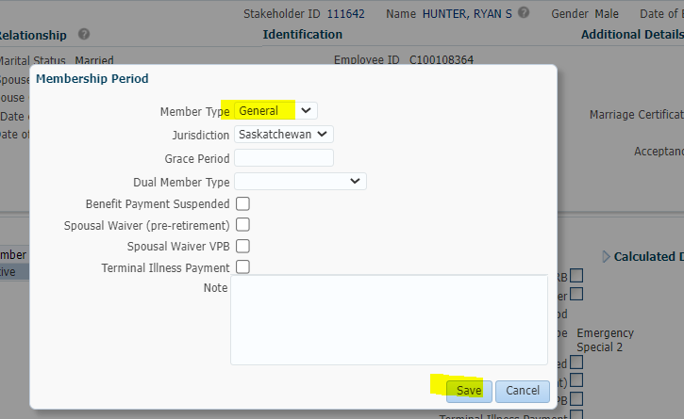

Member now General

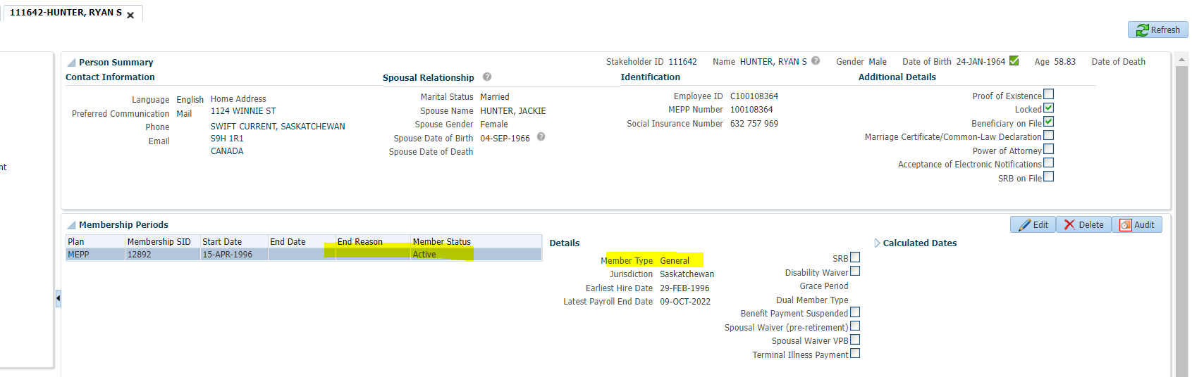

PENWEB

Member is now General Member

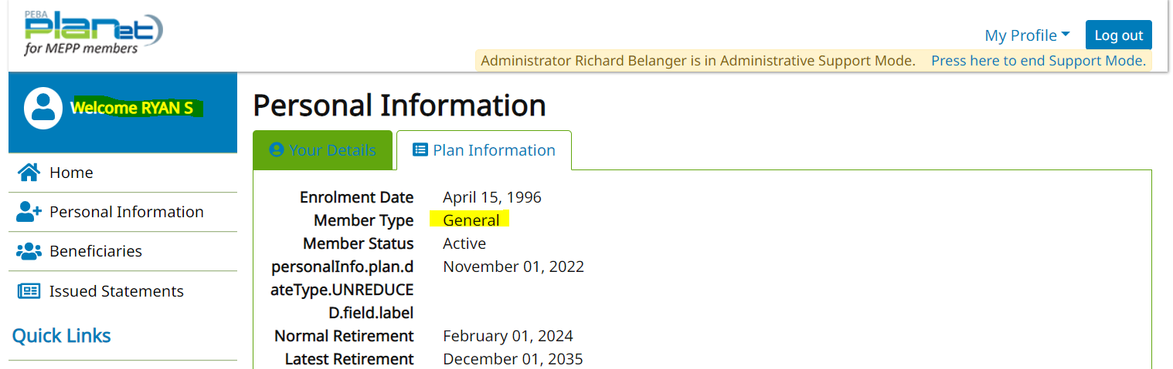

SID = 131593; Member is General

PENFAX

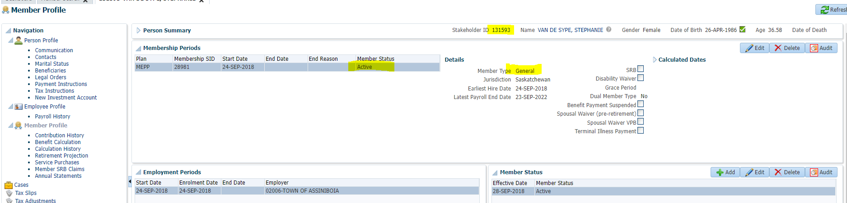

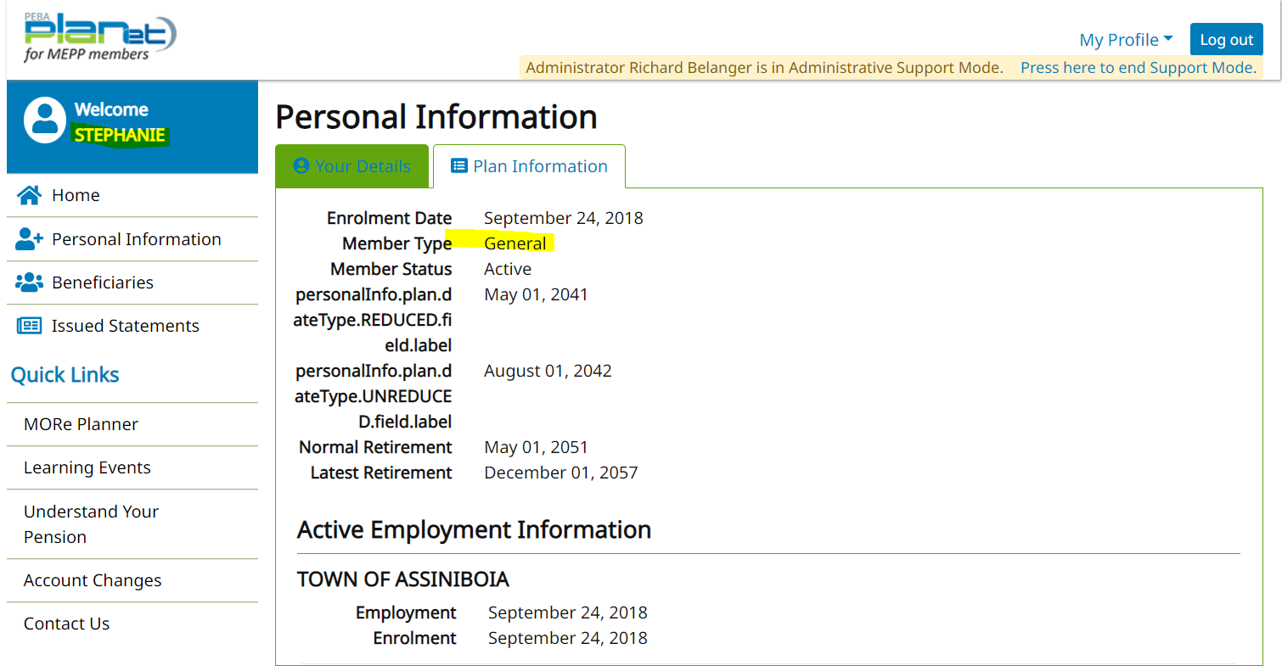

Change member’s Member Type to Designated

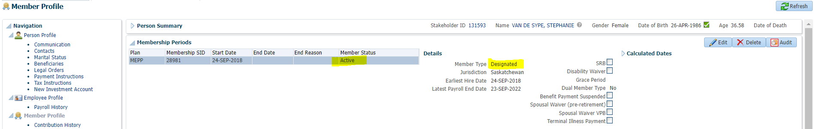

PENWEB

